**Andy An**

**Taiwanese Actress and Singer**



Ady An Yi-xuan was born in Taipei onSeptember 29, 1980. She is a Taiwanese actress and singer, 1.65 meters tall, educated to college level. She completed her degree level course at theTaiwan Hospitality and Tourism College. She did not have a good family experience as a child although her father was very wealthy. Her parents broke up while she was only four years old and both of them remarried.

Ady was brought up by her father and step mother who were strict disciplinarians. She missed the love and caring of her mother and this perhaps explains why she sought close attachments with friends at an early age culminating in her forming a group of close celebrity friends which became known as *An Corporation*.

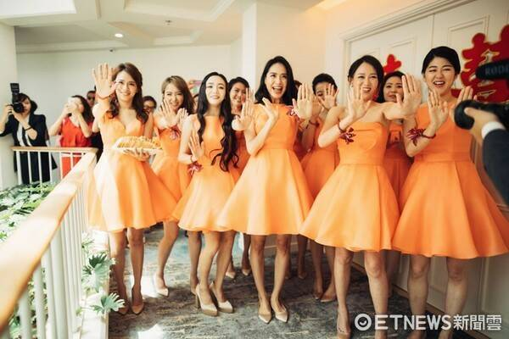

**An Corporation**

The members, among others, included Chen, Shone An, Esther Liu, Bianca Bai, Linda Liao and Kimi Hsia.Ady.

An made her debuted in the Taiwanese entertainment industry in 2000 when she appeared in the drama *Mala Xianshi*. However, it was only in 2004 that she became really famous after a stunning performance in her starring role in the youth idol drama, *The Outsiders* alongside Dylan Kuo. This performance improved her profile to such a level that she was able to venture into an acting career in mainland China.

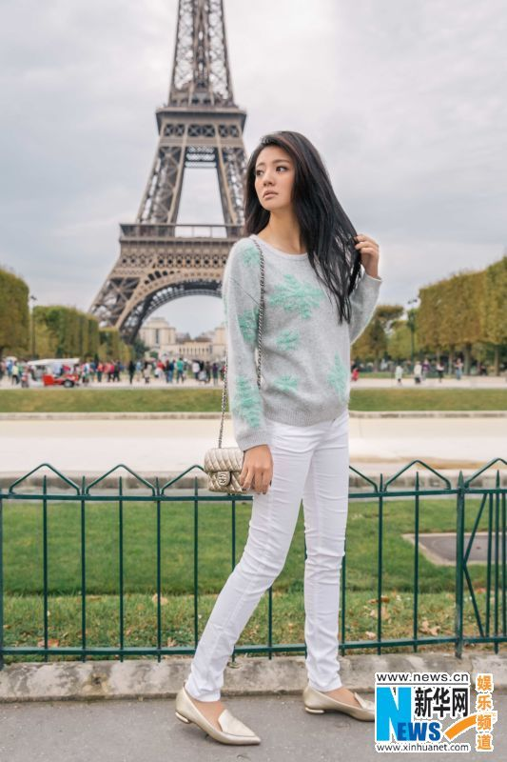

She got a break into mainland China’s film industry in the same year when she secured the lead role in *Chinese Paladin*, an adaptation of the action RPG *The Legend of Sword and Fairy*. This opened up a flurry of opportunities for her in mainland China which she seized and appeared in many starring roles in television drama both in China and in her home country Taiwan. They include *The Legend of Hero* (2005), *The Great Revival* (2006) and *Fox Volant of the Snowy Mountain* (2006). In 2006, she played the leading role in the first race-car series in mainland China, Fast *Track Love*.



Between 2008 and 2014 she starred in a long list of television series both in Taiwan and mainland China. She continued working hard up to 2017 and bagged three nominations namely 2011 nomination for 6th Huading Awards Best Actress (Legend) for her performance in *A Terracotta Warrior, 2013* nomination for 5th Macau International Movie Festival Best Supporting Actress for starring role in *Saving General Yang* and nomination for 2016 8th Macau International Movie Festival Best Actress for her performance in *Perfect Imperfection*.

She has recently announced that she is slowing down to focus on family life. She is married to a 36 year old Macau business man Chen Ronglian Levo. She married him March 15, 2017. The couple had met in late 2014. They do not have any plans to have children yet.

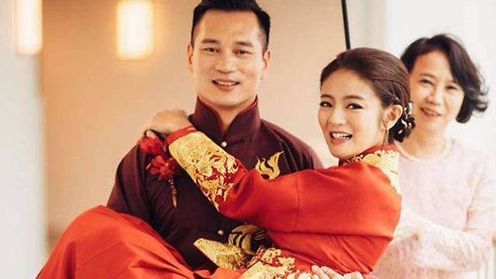

There is an intriguing side to their relationship. According to both of them they were not that impressed at their first meeting. Roglian admitted in a recent interview with the press that Ady’s attitude at that meeting was very disappointing.



As far as Ady was concerned, she said, he was to her, just another person she was meeting. However, Roglian began to develop interest after the second meeting. Ady’s first thoughts on finding out that he was interested was that he only wanted to attract attention to himself by having a celebrity as a girlfriend. Besides, she was aware that many female celebrities are married to wealthy businessmen and was not keen to be counted as one of those.

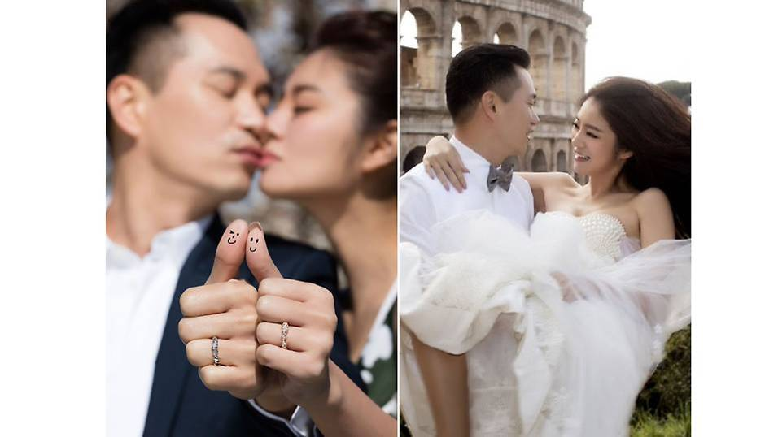

However, Roglian was relentless in his pursuit of Ady and Ady soon found out that they shared similar views on several topics especially on love and relationship. Ady was to admit later that what touched her heart most was that Roglian was willing to share his precious time with her in contrast to what most businessmen would have done. In addition, one single incident in which Rglian drove a long distance at night to deliver medicine for the flu she developed during the day convinced her that Roglian truly had her interest at heart.